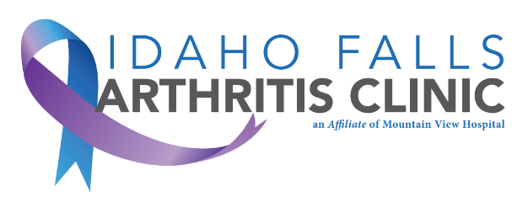
Idaho Falls Arthritis Clinic
Scovilleclinic@mvhospital.net
Phone: 208-542-9080
Fax: 208-542-9081

Dear Valued Patient,

As you are aware, your appointment with us is fast approaching, and we would like to make sure you have all the necessary information to ensure an effective visit.

To ensure that we have a complete understanding of your medical history, it is necessary for you bring at least 6 months’ worth of previous relevant clinic records to your appointment. This includes any laboratory results, diagnostic imaging, and medication records. These records will help us provide you with the best possible care and ensure that we have all the necessary information to make an accurate diagnosis.

Sincerely,

Idaho Falls Arthritis Clinic

